**TCS SHOP NOVA 2018**

College Name: Moradabad institute of Technology College Code: AISHE Code -C-46076

Krishna kumar singh - Create and perform research

Firoj Khan - Perform research And find factual information

Abstract:

Give customers an easy and convenient way to shop from the comfort of their homes on a website that they buy all of their favourite clothes. Our fully hosted ecommerce solution provide a facility of voice search, 24*7 bots support, voice recognition for auto-change recommended products, free voice call & feedbacks forms to find user interest and satisfaction.

Problem Statement:

* In finding product there is no user rating graphs, no result of last 7 days most buying product, No recommended product found for the particular users, user not able to search by voice, user was not able wear product(clothes) on his body virtually, no user interest feedback forms, no voice recognition, no bots support & not give importance to the user interest.

Background Search:

Primary Research:

For this we take interview of our relatives and friends.

Face to Face Interview:

* The people are not satisfied about the search option given on the online websites.For example: sizes of cloth.
* Bots support is not available that help people in buying product.
* People are buy the product less confidently due to less confidence due to absence of virtual reality.
* No user feedbacks forms are present on websites.

Personal Observation:

* People are less confident in buying product.
* Product are seems to costly because no virtual trial room is present on websites.

Secondary Research:

Sales Records:

* In most of the websites sales records of particular product is very high and another one is very low. This is only due to no different recommended products are present according to user interest.

Newspaper Records:

* People are getting bad quality products.
* Difficulty in finding product according to their needs.

Communities Survey(Quora):

* Problem in finding correct size clothes.
* Sometimes tax and shipping charges are not included in total cost.
* No virtual trial room is present.

Approach of the Solution:

We decide to provide more search options for the cloth size search. We will add voice search option so the users that does not able to type buttons can search our products. The data mining is perform on backend. So the user can see more products. Different recommended products are seen to the different users. This will make user more satisfied. 24*7 hour bots support that help user in product selection. We provide free video call facility. All user discussion during this chat is filtered by bots. These bots change the recommended options for the product. User can transfer his/her credit/money to their friends account. The transaction method always help in buying more. In a free time user can fill the forms that helpful in finding different user interests.

We provide virtual trial room so user can find best suited product. Administrator can view sale in single web page.

Solution Description:

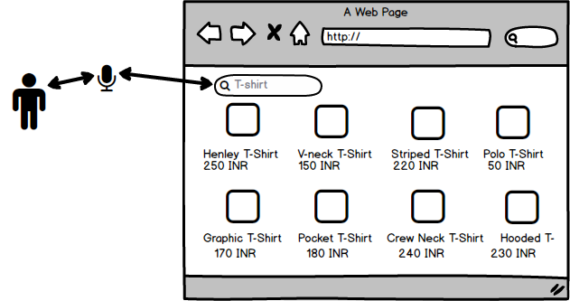

* We will create website by which user can search result by voice commands.

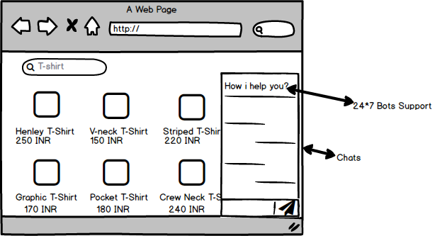

* We will provide bots support for the users. These bots help users in selection of product. They help the users like real person.

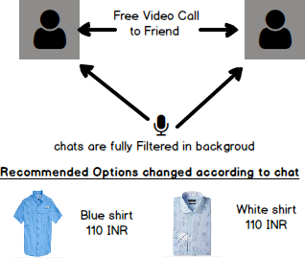

* The user can use free video call option for the discussion about the product. The user voice is filtered by the bots & these bots automatically change recommended options according to user interest.
* The data mining will performed in backend automatically that provide products in bottom that user can like. The graphs represents sale of the product in different countries.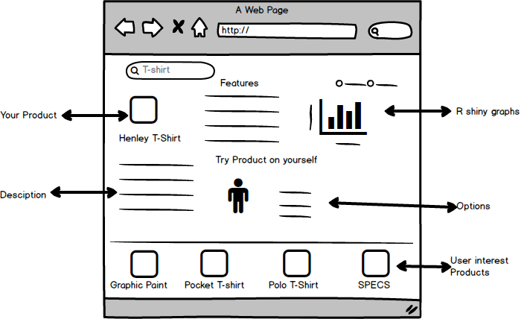

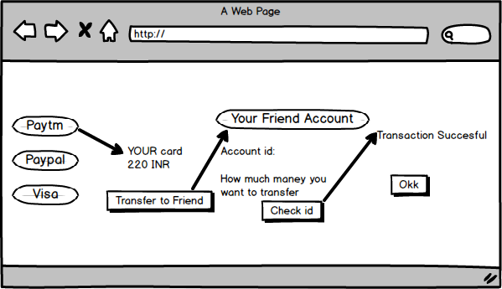

* User can share money/credits with his/her friend that are present in website account.
* In a free time user can fill forms so bots are understand the user interest and modify search according to his/her.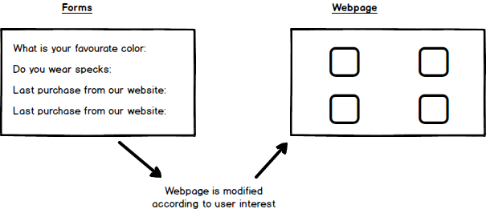

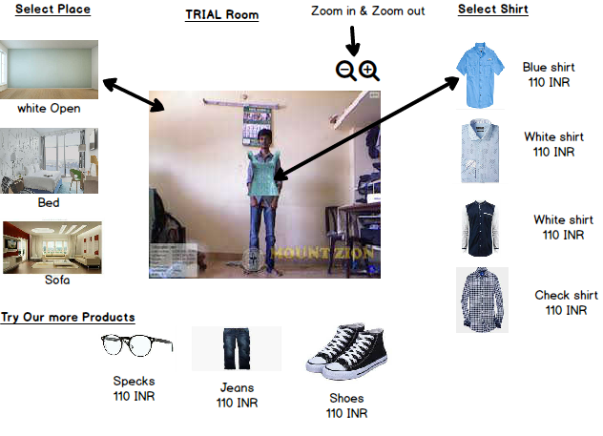

* The user can virtually that how the product feel on his/her body. User can upload his/her image. They can change background and products.

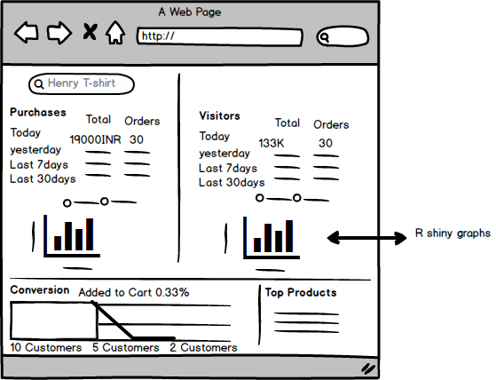

* The administrator can see overall sale in one view.
* They are to see results on the basis of their interest.
* We provide graphs of selling products.
* We provide some forms so user may spend free time on our website.
* All the user activities are recorded in the database.

Technology & Stack Architecture:

* HTML, CSS, Boostrap
* R, MATlAB, RShiny, PHP, JQUery, AJAX.
* Data mining tools(Orange, KNIME).
* Wit.ai and other Artificial intelligence tools.

**Use Case:**

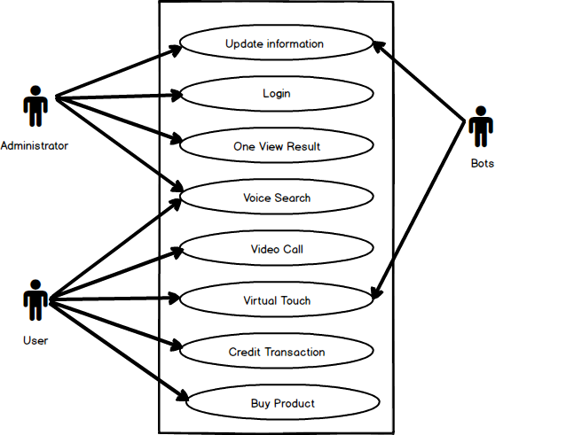

Experiments and Results:

Google voice search Experiment:

Google provides voice search for their user in october 30, 2012. It is very much helpful in finding results on search engine or finding songs on Youtube.

Results:

Provide faster and more accurate result. Sometimes user type wrong spelling or not know the correct spelling. This may give the wrong results. Finally, by this user is more satisfied by Google.

Windows bots support Experiment(In finding windows problem, Cortona, Skype):

The Microsoft provide bots for their users to solve problems.

Results:

Helpful in solving user queries. Make users more satisfied.

Youtube relevant video search:

Google perform data mining in back end.

Results:

User spend more time on Youtube.

Future & Scope of the solution:

* User can buy products by using Android app.
* Provide comparison between different websites product costs.
* Remove delay in delivery of products.
* More bots support.
* User can control full website using voice commands.
* More search options are added.

Conclusion:

This solution provide more creative shopping that user can do online. Many problems are solved by above methods. It provide faster, more comfortable with no restriction shopping. Bots are provide services as like real person. Trial rooms are develop the trust between users. It make a shopping more enjoyable and easier than real world shopping.